**For each of the following graphs, try to do the following. Write your answers out in sentence using the variable names.**

1. **Indicate whether there is a main effect of IV1**
2. **Indicate whether there is a main effect of IV2.**
3. **Indicate whether there is an interaction**
4. 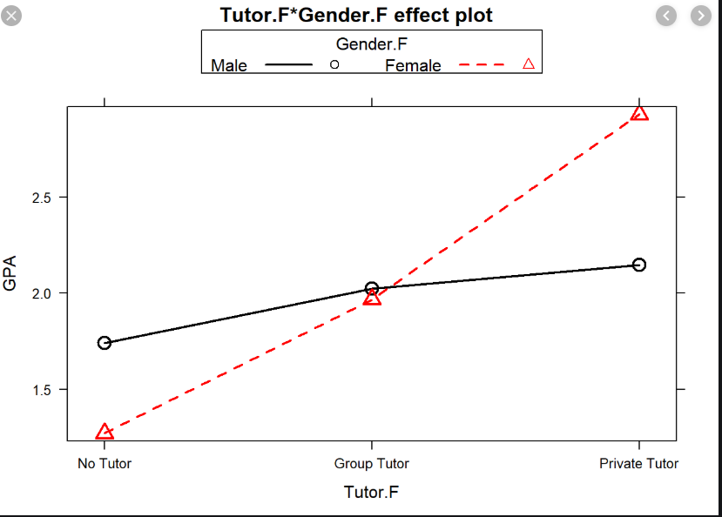**The following shows how a person’s gender and their tutoring status impacts their GPA.**

|  |  |  |
| --- | --- | --- |
|  | **Male** | **Female** |
| **Non-athlete** | 7.48 | 10.06 |
| **Athlete** | 6.46 | 7.0 |

1. **The following depicts how many candies were eaten on average by male and female students who were either athletes or not.**
2. **The following depicts how a person’s HS GPA and whether they own a computer (PC) or not, predicts their college GPA.**

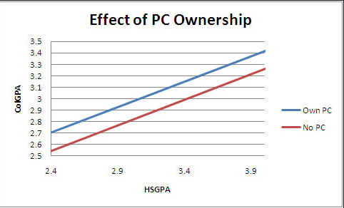

1. **The following depicts how many things a person remembers that an interaction partner said about them or another person.**

|  |  |  |
| --- | --- | --- |
|  | **Funny** | **Serious** |
| **Self** | 5 | 5 |
| **Other** | 3 | 3 |

1. **The following shows how petting a cat or dog prior to an exam affects their stress levels before and after the exam.**

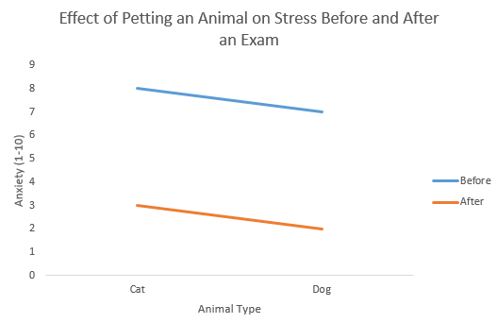

1. **The following shows us how much people enjoy eating ice cream depending on its flavor and what it was served in.**

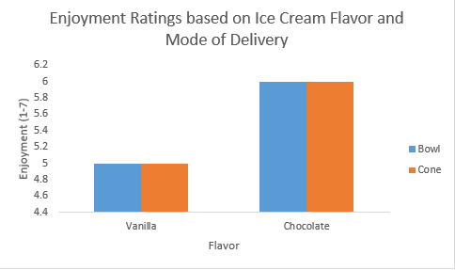

1. **The following depicts how happy men and women reported feeling after varying doses of a depression medication.**

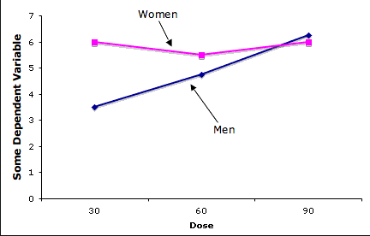

1. **The following shows how three programs impacted weight loss for males and females.**

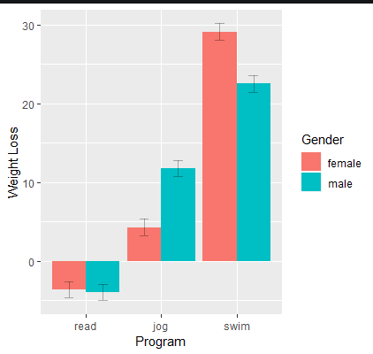

|  |  |  |
| --- | --- | --- |
|  | **Negative Music** | **Positive Music** |
| **Low Self-Esteem** | 72 | 77 |
| **High Self-Esteem** | 90 | 85 |

**9. The following table shows people’s ratings of happiness (on a scale from 1-100) where higher numbers are linked to greater happiness. Participants with high and low self-esteem were randomly assigned to listen to music that would put them in a positive or negative mood prior to rating their happiness.**

**10. This graph shows reaction times for participants to respond to words on a screen. The words were either shown in blue or red font and the screen background was either white or black.**

**11. Researchers created numerous dating profiles for a popular dating website. For each, they used a different photo of the same woman with the same written profile. They had photos of this woman either making eye contact (or not) with the camera. She also posed in three ways: not smiling, smiling, or what the researchers considered a “flirty-face.” The researchers measured how many new people contacted each profile on average across three months.**

